Norovirus in Vermont
PART I. OUTBREAK DETECTION

On the morning of February 5, the mother of a young child called the Vermont Department of Health (VDH) to report a possible foodborne outbreak. The woman’s child, age 5 years, and two neighborhood children, ages 7 and 10 years, had become ill with vomiting and diarrhea within 12 hours of each other. The child aged 5-years had become so sick that her mother had taken her to the emergency department at the local hospital.
The mother reported that her child initially complained of nausea around 10:00 a.m. on Monday, February 2. The nausea was followed by vomiting and multiple episodes of diarrhea. The child was unable to eat or drink anything without vomiting. Toward evening, the child became listless. The woman took the child to the emergency department where she was noted to be dehydrated and that she had a fever. Stool and blood specimens were collected, and the child was treated with intravenous fluids and released.
The mother called the emergency department the following day to receive the test results for her child. A nurse told her that preliminary stool culture results were “negative for the usual bacteria.”
The two neighborhood children had had similar symptoms (i.e., nausea, vomiting, diarrhea, and fever) but had not become as ill as the woman’s child. Their symptoms started a few hours earlier than her child’s. Both had returned to school the day after becoming ill.
The three children usually did not play together but had attended a birthday party on the morning of Sunday, February 1. The mother was concerned about homemade ice cream that was served at the party because she had heard it had been prepared using raw eggs.
After confirming the mother’s information with the emergency department physician, VDH staff called the mother who had organized the February 1 birthday party. The woman reported that her own child was well (except for a cold). Other parents had called her, however, saying that their children had become ill with vomiting and diarrhea.
The woman reported that her son’s birthday party had occurred at a private indoor swim club in Essex, Vermont, close to Burlington. Approximately 30 children and adults were in attendance. The children ranged in age from 5 to 10 years. Not all of the children attended the same school.
Cake, ice cream, and canned drinks had been served at the party. All refreshments had been commercially prepared. The ice cream had not contained raw eggs.
The majority of children had played in the pool at the swim club before presents were opened and cake and ice cream were served. Two children who later became ill had left the party before cake and ice cream were served to attend another birthday party.
The mother provided a list of party attendees, indicating which ones she knew had been ill, and their telephone numbers. She also provided the name and telephone number for the swim club manager.
PART II. HYPOTHESIS GENERATION
VDH investigators notified the district health department of the problem and then contacted the manager of the private swim club. The manager stated that he was dealing with a “problem” and refused to talk with health department investigators. He suggested that they leave their telephone number and he would call them back if he had time.
After VDH investigators stated the reason for their call and reassured the swim club manager that the health department needed to investigate the reported illnesses so that the source could be found and actions could be taken to prevent others from becoming ill, the manager spoke with investigators.
The manager had not heard about the illnesses associated with the February 1 birthday party, but had received reports of illness among other persons who had used the pool during the weekend. Rumors were circulating that participants in the infant-mother swim class (that last met on Saturday, January 31) were sick with “stomach flu.”
The manager provided VDH investigators with the names and contact information for persons who had complained to him about being ill and for members of the infant-mother swim class.
VDH investigators, with the assistance of district health department staff, contacted households of persons who had visited the swim club and reported illness since January 27 to VDH, the mother organizing the February 1 birthday party, or the swim club manager. Investigators asked about specific symptoms, the date of illness onset, and the most recent date the ill person had visited the swim club.

On the basis of these calls, 21 persons were identified as having attended the swim club and having reported being ill (Table 1). Signs and symptoms included vomiting (90%), nausea (81%), abdominal cramps (67%), diarrhea (48%), fever (48%), and headache (43%). Symptoms began a median of 30 hours (range: 8−62 hours) after visiting the swim club.
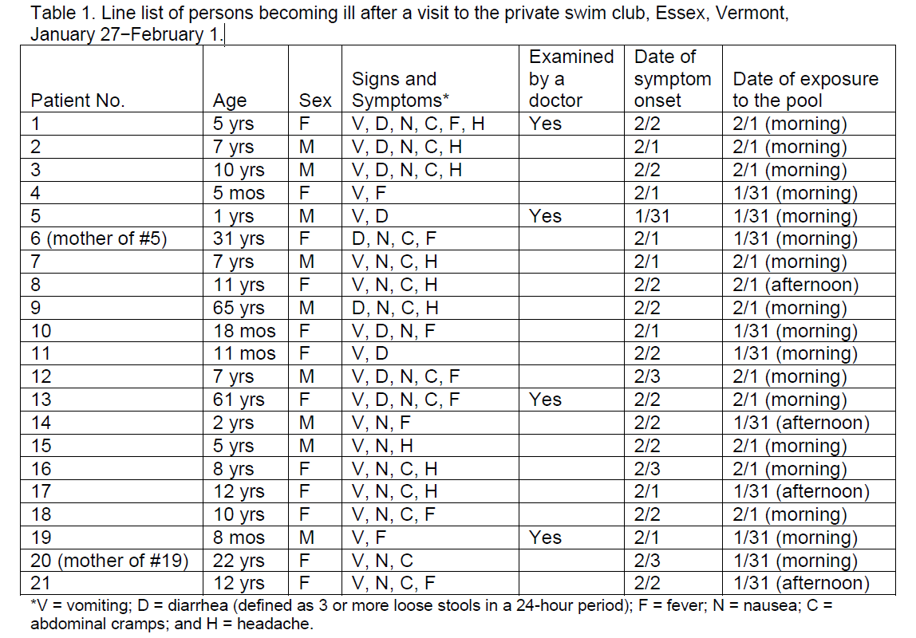

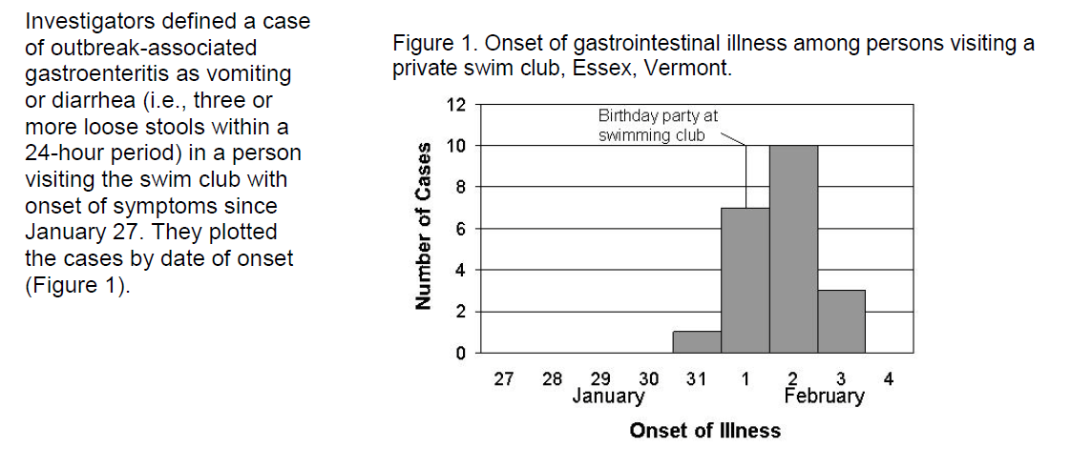

During the calls, multiple parents, who had been at the pool on January 31 noted that the water in the pool had been cloudy. One parent had reported the pool’s condition to the lifeguard and was told that the cloudiness resulted from chemicals added to the water. The parent later saw another swim club staff member collecting water from the pool for testing. No one reported having seen a fecal incident or vomiting while they were at the pool.
On the basis of the initial findings, VDH investigators believed that the gastrointestinal illness was consistent with norovirus infection. They hypothesized that the virus was spread by exposure to the pool at the private swim club on Saturday, January 31, or Sunday, February 1. The district health department arranged collection of stool specimens from 10 patients for norovirus testing at the Centers for Disease Control and Prevention (CDC), using reverse transcription-polymerase chain reaction (RT-PCR).

PART III. ENVIRONMENTAL STUDIES AND WATER QUALITY INVESTIGATION
On the afternoon of February 5, VDH environmental health investigators undertook a comprehensive evaluation of the private swim club associated with the gastroenteritis outbreak. Investigators met with the swim club manager, the pool operator, and staff on duty during the outbreak period.
The goal of the evaluation was to gain a thorough understanding of the design features of the swim club and its operations so that investigators could explore the suspected source of the outbreak and assess factors that might have contributed to its occurrence.

VDH environmental health investigators learned the following information about the swim club and its operations. The club actually had two indoor swimming pools: a smaller activity pool and a lap pool. The smaller activity pool had been used for the February 1 birthday party and the infant-mother swimming class. The club also had a hot tub, men’s and women’s locker rooms, a sauna, and a party room where food was served for private events (Figure 2).

The lap pool, activity pool, and hot tub were situated close to each other (Figure 2). The men’s and women’s locker rooms were adjacent to the pools. Each locker room had a diaper-changing station. Hand-washing signs were posted throughout the club.

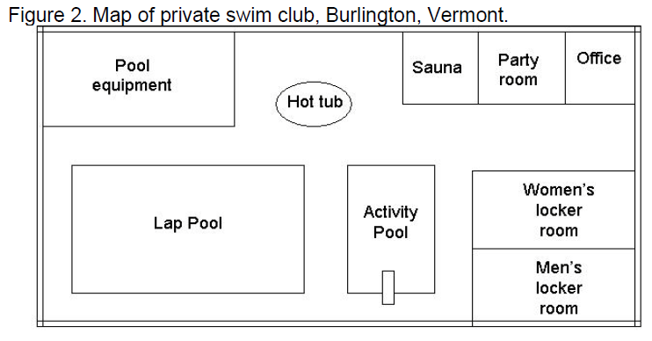
The swim club was popular for children’s parties because the activity pool had a slide. Swim classes were also held at the club; classes for children and infants-mothers were held in the activity pool. The club did not have a snack bar. Food for private parties was brought in by event organizers. Pool staff did not help prepare or distribute food for these special events.
Municipal public water was used to fill the pools. The water in the three pools circulated separately for treatment, moving first through a hair and lint strainer (where the larger debris in the water was removed) and then to a pump. From the pump, the water was forced through a rapid sand filter, where it was then disinfected. After disinfection, the water was heated and returned to the pool through a series of inlets in the pool wall.
Water recirculated continuously in all three pools. State law required turnover rates of 6 hours for the lap pool, 2 hours for the activity pool, and 1 hour for the hot tub. Flow meters measured the flow rate for filtration of the water from each pool.
Liquid sodium hypochlorite was used to disinfect the pools at the swim club. An automated disinfectant feeder was attached to the filtration system, helping to mix the disinfectant with the water. A device operating in conjunction with the disinfectant feeder automatically adjusted the pH of filtered and chlorinated water.
Pool operations at the private swim club were performed by lifeguards. However, they received no standardized training or certification in pool maintenance but took instructions from the pool operator who serviced the pool equipment and made decisions regarding water treatment. Staff reported that they tested the water from each pool twice daily; but no records of the results were maintained.

Because no records of water chemistry were maintained at the swim club, aquatic staff were asked to recall water conditions during the weekend and the quantity, time, and type of chemical solutions they had added to each pool. Staff were also asked about any unusual occurrences (e.g., fecal incidents, vomiting, or deviations from normal operating procedures).
On Friday, January 30, no abnormalities in pool water appearance were noted by staff, and testing of water from all three pools was reported as being “normal”. Staff had reported a marked cloudiness of the water in the activity pool on Saturday and that patrons had complained about the cloudiness. No action was taken, despite complaints from patrons concerning water quality, because the pool operator was off-duty.
The cloudiness of the activity pool persisted through Sunday morning, February 1. Chlorine and pH readings taken by staff at that time were “below acceptable standards.” The pool operator was called, and staff were instructed to superchlorinate the pool with several cups of 65% calcium hypochlorite granules.

On Monday morning, the pool operator returned to duty at the swim club and tested a water sample from the activity pool. The sample revealed a total chlorine of 1.5 parts per million (ppm), a free available chlorine of 0.5 ppm, and a pH of 6.8.

Upon his return to the swim club, the pool operator found a kink in the chemical feed pump tube that supplied sodium hypochlorite to the activity pool water. The kink was repaired and the pool was superchlorinated again Monday night (February 2). The pool operator reported that the chlorine and pH were within normal limits when tested Tuesday morning, February 3. These findings were confirmed by VDH investigators.

The swim club did not have standard operating procedures detailing how to respond to abnormal pool chemistries; how to handle water quality complaints; or how to respond to fecal incidents, vomiting, or problems when the pool operator was off-duty. Because aquatic staff turnover at the pool was high, the swim club manager believed that the pool operator should make decisions about pool problems on a case-by-case basis.

PART IV. EPIDEMIOLOGIC STUDY TO TEST THE HYPOTHESIS
After the environmental health assessment of the private swim club, VDH investigators conducted an epidemiologic study to confirm suspicions regarding the source of the outbreak and to identify risk factors for infection.
The swim club manager estimated that 250 persons had visited the club from Friday, January 30−Monday, February 2. Pool attendance records and contact information were available for swim club members. The club manager also provided contact names for group events held at the pool during this time period.
VDH investigators decided to undertake a cohort study because the outbreak was confined to a well-defined group of persons (i.e., those individuals who had visited the pool during January 30–February 2) and the exposure of interest was known. A cohort study also permitted investigators to identify all cases and calculate attack rates.
Investigators planned to contact swim club members who had been at the club during the outbreak period and persons who had attended the special events during that weekend. Each person (or his or her parent) was to be asked about recent gastrointestinal illnesses; onset of symptoms; specific swimming pool exposures; food and water consumption while at the swim club; use of locker rooms, showers, and toilets; and whether they witnessed anyone vomiting or any fecal incidents at the pool. A VDH epidemiologist developed a questionnaire to collect the information.

VDH and district health department staff members were trained to administer the questionnaire by telephone for the cohort study. Interviews were conducted during February 12−22. Information was collected for 189 (74%) of the 255 persons who had visited the swim club during the period of interest.
A case was defined as vomiting or diarrhea (i.e., three or more loose stools within a 24-hour period) in a person who had gone to the swim club during the outbreak period and who experienced symptoms within 72 hours of visiting the facility. Investigators calculated attack rates and relative risks for different exposures at the club and set a P value of 0.05 as the cut-off for statistical significance.
Fifty-two (33%) of the 160 persons who either swam in or accompanied children who swam in the activity pool met the case definition. Only one (4%) of the 28 persons who only used other parts of the facility (e.g., lap pool, hot tub, or locker rooms) met the case definition. Because of these findings, further analyses were restricted to the 157 persons who either swam in or accompanied children who swam in the activity pool and who provided investigators complete information.
Attack rates were 0% (0/21) for persons who used the activity pool on January 30; 57% (25/44) for persons who used the pool on January 31; 29% (22/75) for persons who used the pool on February 1; and 12% (2/17) for persons who used the pool on February 2. Six persons, including three who were ill, had exposures to the pool on multiple days. Attack rates also varied by other exposures in and around the activity pool (Table 2).

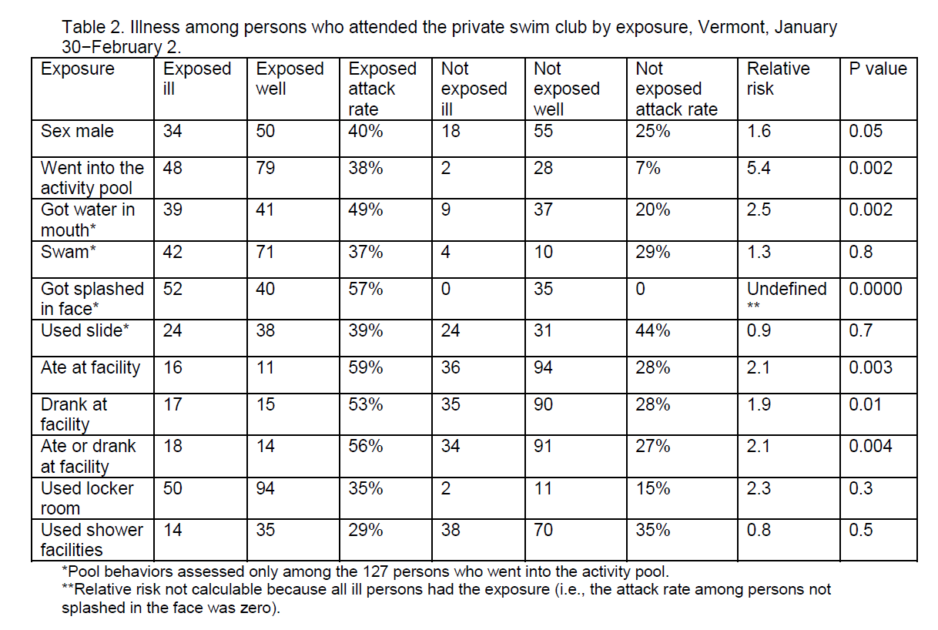

In the cohort study, going into the activity pool at the private swim club was significantly associated with illness. Among persons who went into the activity pool, getting water in the mouth and getting splashed in the face were significantly associated with illness. Neither swimming (versus wading) nor using the slide was associated with illness.

Use of the locker rooms or showers at the swim club was not significantly associated with illness. However, eating and drinking at the swim club were significantly associated with illness.

Eating and drinking at the facility accounted for only 18 (35%) of the 52 cases of gastrointestinal illness. Furthermore, investigators noted that persons who ate and drank at the facility were largely limited to children attending the birthday party on the morning of February 1, when the water in the activity pool was highly suspect in terms of maintenance failures and contamination.

When analyses were stratified by date of exposure to the swim club, persons eating at the facility or drinking at the facility were at no greater risk for illness than other persons attending the club on the same day. In addition, multivariate logistic regression analysis identified the date of attendance at the facility and getting water in the mouth were the only factors significantly associated with illness. Investigators concluded that food and drinks were not independent risk factors for illness.

PART V. CONTROL AND PREVENTION MEASURES
The cohort study confirmed suspicions that the outbreak was spread by exposure to water in the activity pool at the private swim club and likely resulted from a fecal incident in the pool when the chlorinator was not functioning properly.

Five of 10 stool specimens collected from ill persons and submitted to CDC tested positive for norovirus by RT-PCR testing. The nucleotide sequences of the amplified RT-PCR products were identical, indicating a single contamination event at the activity pool.
The chlorinator was fixed and, at the time of the pool evaluation, pool chlorine and pH were consistent with recommended national standards.

VDH investigators believed that a lack of pool staff training, inadequate record-keeping, and lack of standard operating procedures contributed to the outbreak. Consequently, VDH investigators recommended that all pool staff at the club be trained in water testing and basic pool maintenance and that the pool operator remain onsite or be readily available for consultation during weekends, when pool usage was usually highest. Investigators also recommended that the club keep records of routine pool chemistries and pool maintenance.

In addition, investigators recommended that the swim club develop written standard operating procedures and emergency response plans detailing how water-quality complaints should be handled, the correct response, and lines of communication to the pool operator. In particular, VDH investigators recommended the development of a fecal incident response policy.

VDH investigators helped the swim club manager and pool operator develop a written policy for responding to fecal incidents. As part of the policy, staff were to document each fecal incident by recording the date and time of the event, whether it involved a formed or diarrheal stool, and the free chlorine levels and pH at the time the event was detected.

Pool management distributed the fecal incident response policy to all swim club staff and held special classes to review the approach to a fecal incident. New staff members received the policy and viewed a short video about the steps necessary to respond to a fecal incident.
After the investigation, members of the private swim club voiced concern about the adequacy of actions taken to prevent future waterborne outbreaks at the club. The club manager asked VDH staff to meet with interested club members.

EPILOGUE

The number of recreational water-associated outbreaks in the United States has increased substantially since 1978 when CDC first began collecting reports.3 The increase has been caused by outbreaks of gastroenteritis (Figure 3) and likely results from a combination of factors, including the emergence of chlorine-resistant pathogens (e.g., Cryptosporidium), increased participation in aquatic activities by the public, and an increased number and variety of aquatic venues.

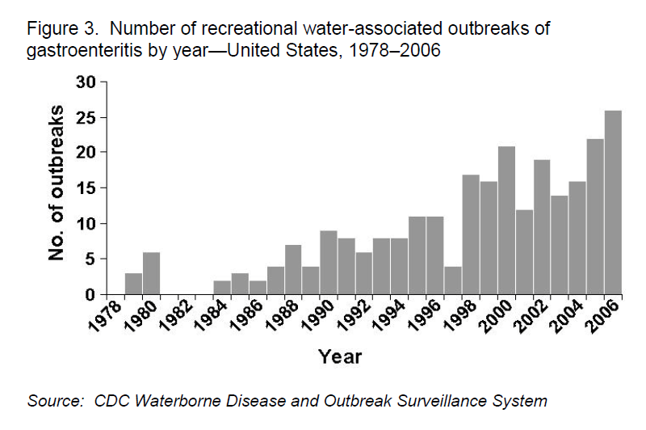
Source: CDC Waterborne Disease and Outbreak Surveillance System
During 2005−2006, a total of 78 recreational water-associated outbreaks were reported in the United States, resulting in 4,412 cases of illness. Fifty-eight (74%) of the outbreaks occurred at treated water venues, resulting in 94% of the cases of illness.
As experienced in Vermont, problems contributing to outbreaks associated with treated recreational water in 2005-2006 include low disinfectant levels, inadequate water-quality monitoring, breakdowns of equipment and lengthy detection times, inadequately trained aquatic staff, and unclear chains of communication for resolving problems. Unfortunately, these problems are not limited to facilities associated with waterborne outbreaks. In a study of pool inspections at six sites across the United States, over half of all pools had at least one violation. Water-chemistry violations comprised 38.7% of total violations, followed by violations of the filtration and recirculation system (38.6%), and policy and management violations (22.7%). Approximately 8% of pools were closed immediately because of public health concerns.4

Prevention of outbreaks in treated recreational water venues is likely to be accomplished only through concerted efforts by pool operators, the public, and public health professionals.

- Pool operators should employ multiple mechanisms to prevent contamination of pools and transmission of pathogenic agents, including effective facility design and pool maintenance. Operators should implement diarrhea-exclusion policies and disinfection guidelines after fecal incidents. In addition, staff should be trained to perform pool operations, enforce policies, and educate young bathers and their parents about healthy swimming practices.

- The public should follow basic guidelines for healthy swimming. They should avoid swallowing water and stay out of the pool when they have diarrhea. Because fecal shedding of pathogens is common, bathers should use appropriate hygienic measures around pools (e.g., showering before swimming, taking children on frequent bathroom breaks, and changing diapers in the bathroom instead of at the poolside). Pool policies and design should support these efforts by the public. Increased public awareness of pool safety issues and action can promote better maintenance of pools by operators.

- Public health professionals should lead prevention efforts that include surveillance, health education, epidemiologic and laboratory studies, and environmental health research. Public health professionals should (1) require and improve training for pool inspectors, (2) update pool codes to stay current with changing pool designs and needs, and (3) lead efforts to educate aquatic staff and the public. They should also work with industry representatives in developing easier, more effective methods for treating pool water. In addition, because the majority of gastrointestinal illnesses can be spread by water, food, person-to-person contact, and animal-to-person contact, investigators should keep an open mind when investigating such cases and consider all possible sources of transmission during the investigation of an outbreak.

Improved pool operator and public education combined with more effective methods of water treatment should increase swimming safety and reduce the risk for waterborne diseases associated with recreational water facilities.

REFERENCES
1. Centers for Disease Control and Prevention (CDC). An outbreak of norovirus gastroenteritis at a swimming club—Vermont, 2004. MMWR Morb Mort Wkly Rep 2004;53:793−5. Available at http://www.cdc.gov/mmwr/preview/mmwrhtml/mm5334a5.htm. Accessed on September 18, 2010.

2. Podewils LJ, Blevins L, Hagenbuch M, et al. Outbreak of norovirus illness associated with a swimming pool. Epidemiol Infect 2007;135:827−33.

3. Yoder JS, Hlavsa M, Craun GF, et al. Surveillance for waterborne disease and outbreaks associated with recreational water use and other aquatic facility-associated health events—United States, 2005–2006. MMWR Surveill Sum 2008;57(No. SS-09);1−29. Available at http://www.cdc.gov/mmwr/preview/mmwrhtml/ss5709a1.htm. Accessed on September 18, 2010.

4. Centers for Disease Control and Prevention (CDC). Surveillance data from swimming pool inspections—selected states and counties, United States, May−September 2002. MMWR Morb Mort Wkly Rep 2003;52:513−16. Available at http://www.cdc.gov/mmwr/preview/mmwrhtml/mm5222a1.htm. Accessed on September 18, 2010.

